YPC INTERNATIONAL COLLEGE



BSc (Hons) Multimedia Computing

Software Implementation and Testing

(Demo replacement report)

Coursework 2

Problem Solving in Multimedia Computing

4118COMP

Miss Aniza

BMC1904254



897147

Contents

Age Verification 4

Home page 5

Categories pages 6

Other features 9

# Age Verification

Proposal:



There are changes worth mentioning from the proposed login popup versus developed age verification page:

Justification: it is faster to click a proceed or leave button rather than to fill up a whole form. As website developers know, the first 7 seconds a user spend on a website are critical in determining if they will stay for the rest of the pages.

Developed output:

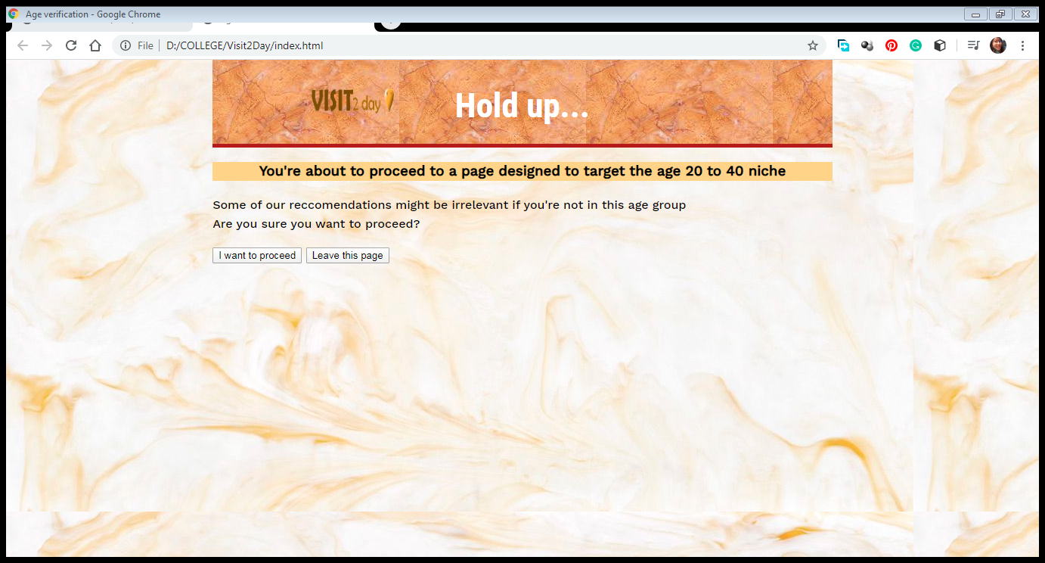

# Home page

Proposal:

There are also changes worth mentioning at the home page. Such was the initial design plan for home page. The revolving banner at the left side has been removed so as to get the desired full-screen layout. The transparency effect has been maintained and can be seen on mouse hover.

Developed output:

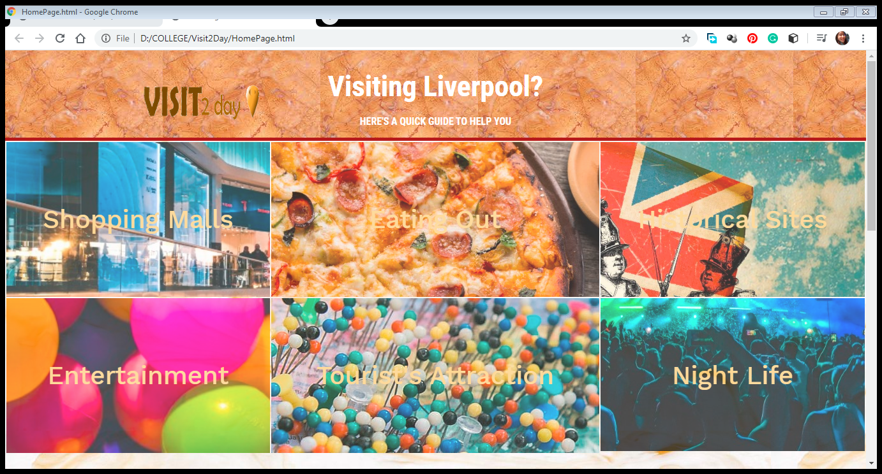

# Categories pages

Proposal:



Developed output:

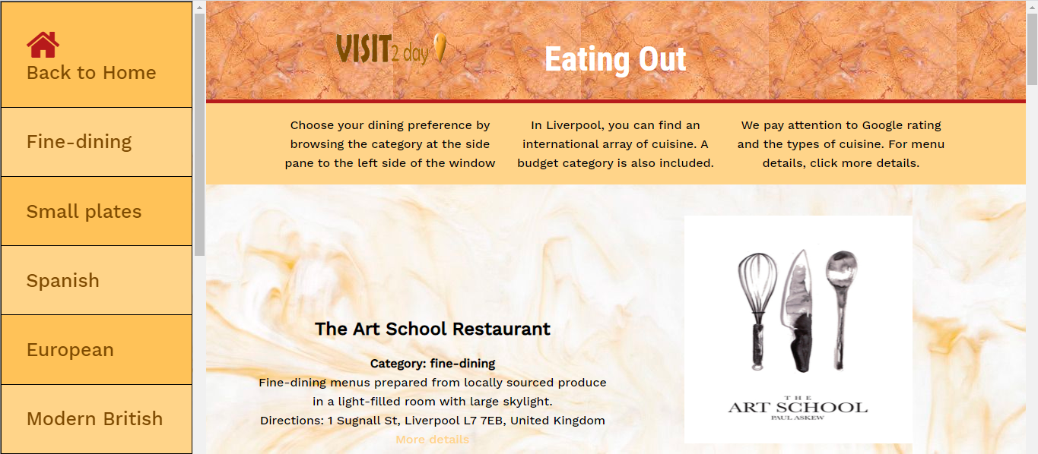 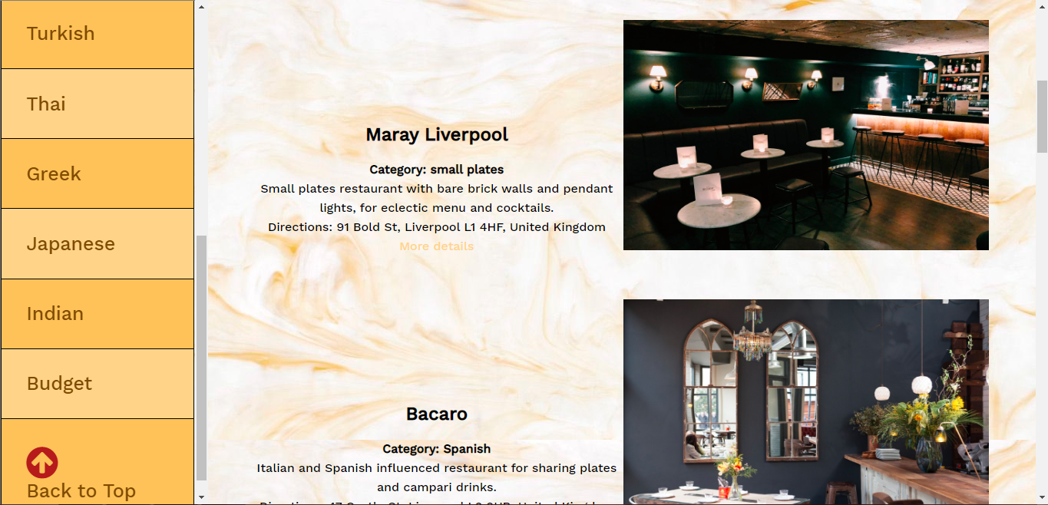

The proposed layout was ditched due to causing confusion for user and developers alike. Form the user Point-of-View, after a few scrolls down the page. It gets confusing which text belong to which image.

On the other hand, from a developer’s Point-of-View, the code is more manageable in the latter design where an image with its related text will each be in one <div> and both will be wrapped together in a <section>, hence each section literally just represents one place (image + information). Developers just need to scroll to the targeted <section> to do any modification such as updating information about a place, or add new <section> to add new information, or remove an existing <section> to delete an existing information.

Abstraction:

|  |  |  |
| --- | --- | --- |
|  | <section>  <div> image1 </div>  <div> info1 </div>  </section>  <section>  <div> image2 </div>  <div> info2 </div>  </section> |  |

Implementation:

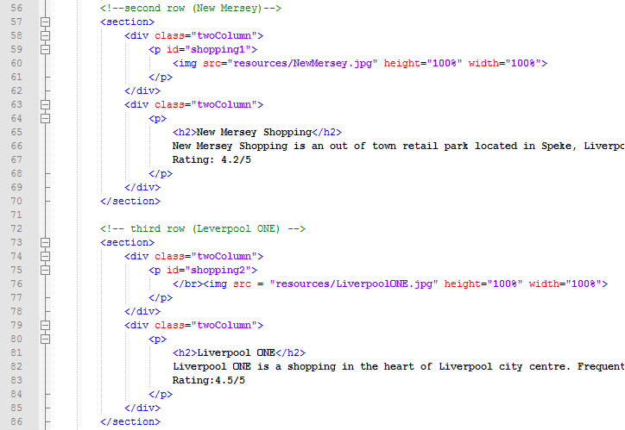

Meanwhile, in the former design, one <section> will contain two <div> which represents two images, and another <section> will have another two <div> which contain the texts for the two images from the previous <section>. There’s no clear management of the code and it is hard edit, add, or remove any content if required so in the future.

# Other features

It is also apparent that the pages follow an orange-colored theme as in the proposal to convey a mood of fun and happiness.



Other changes to mention includes the “favorites” feature. Initially in the home page, one of the six categories are to check the favorited location. However, since our target audience are people aged between 20 to 40 years, it is wise to include a night life category because that’s the strongest age group to target for this category and Liverpool is known to have some of the liveliest night life to have it go ignored in this website. So, the opportunity cost of having the Night Life page is eliminating the Favorites feature. Thence there is no Favorites page, thence the login feature is replaced by age-verification.